Hill Lane Surgery
Newsletter
March 2020

Hello and welcome to our newsletter.

Important information about the coronavirus (COVID-19)

If you are concerned that you may have Coronavirus or may have come into contact with someone who has, the NHS 111 online service has created coronavirus pages that tell patients what they should do based on their particular circumstances. These can be accessed at

https://111.nhs.uk/service/covid-19

The NHS across Hampshire and Isle of Wight will be better prepared for outbreaks of new infectious diseases, if the public follows Public Health England advice.

The NHS has put in place measures to ensure the safety of patients and staff which may mean your patient experience is subject to change.

The Chief Medical Officer announced on Friday 13 March that the country is moving into the ‘Delay’ stage of the response to coronavirus (COVID-19).

The new advice issued by the Chief Medical Officer is to stay at home for 7 days if you have either:

▪ a high temperature or
▪ a new continuous cough

Do not go to a GP surgery, pharmacy or a hospital. You do not need to contact NHS 111 to tell them you're staying at home.

Use the NHS 111 online coronavirus service if:

▪ you feel you cannot cope with your symptoms at home
▪ your condition gets worse
▪ your symptoms do not get better after 7 days

Only call 111 if you cannot get help online.

Everyone is being reminded to follow Public Health England advice to:

▪ Always carry tissues with you and use them to catch your cough or sneeze. Then bin the tissue, and wash your hands, or use a sanitiser gel.
▪ Wash your hands often with soap and water, especially after using public transport. Use a sanitiser gel if soap and water are not available.
▪ Avoid touching your eyes, nose and mouth with unwashed hands.
▪ Avoid close contact with people who are unwell.

Information remains subject to regular change and updates. More information can be found on the NHS website.

For the latest Covid-19 advice please visit www.nhs.uk/coronavirus

On a lighter note, Dr Enelka is no longer with the practice. Although she was only here for a short period of time she will be extremely missed, good luck to her for the future. We would like to welcome our new Doctor, Dr Philippa Keech.

Kind Regards
Laura
Practice Administrator
Hill Lane Surgery

'Try the new NHS App’
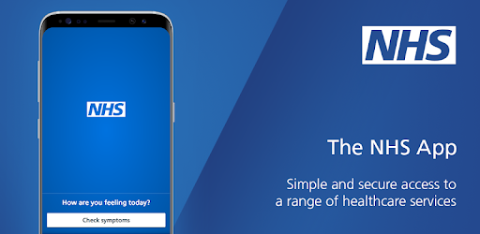
You can now use the new NHS App, a simple and secure way to access a range of NHS services on your smartphone or tablet.
You can use the NHS App to check your symptoms and get instant advice, book appointments, order repeat prescriptions, view your GP medical record and more.
If you already use our Hill Lane website, you can continue to use it. You can use the NHS App as well.
For more information go to www.nhs.uk/nhsapp
(You might also need to review existing website content to make sure it covers the different options patients have to connect with online services.)

https://www.jostrust.org.uk/about-us?gclid=CjwKCAiAhfzSBRBTEiwAN-ysWIVlPzyexe1oe2o5AZ3ZG0S500W5xKV9ymS5hBKyq90IyKuUZhqHARoCWPkQAvD_BwE
Please call the surgery to book an appointment if your smear is due. Please click on the link above for more information, and answers to lots of questions about cervical screening.
"A smear test lasts 5 minutes. The Impact of cervical cancer lasts a lifetime"
Attend your smear test.

Reduce your risk.

